**ADVENTURE WORKS**

Adventure Works Cycles, the company on which the Adventure Works sample databases are based, is a large, multinational manufacturing company. The company manufactures and sells metal and composite bicycles to North American, European and Asian commercial markets. While its base operation is in Bothell, Washington with 290 employees, several regional sales teams are located throughout their market base.

In 2000s, Adventure Works Cycles bought a small manufacturing plant in Mexico. Which manufactures several critical subcomponents for the Adventure Works Cycles product line. These subcomponents are shipped to the Bothell location for final product assembly. In 2001, this manufacturing plant became the sole manufacturer and distributor of the touring bicycle product group.

Coming off a successful fiscal year, Adventure Works Cycles is looking to broaden its market share by targeting their sales to their best customers, extending their product availability through an external Web site, and reducing their cost of sales through lower production costs.

1. Create the Data Model as Below

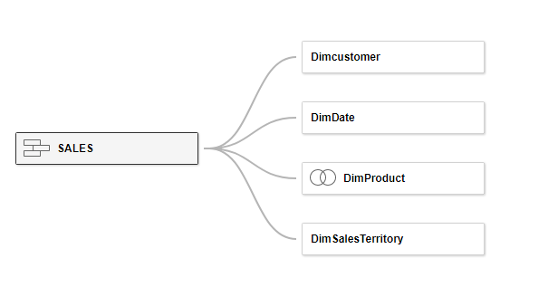

Requirement : Fact Internet Sales is Union of 2 tables Fact_Internet_Sales and Fact_Internet_Sales_New

Dim Product is left Join DimProduct < DimProductSubCategory < DimProductCategoory

Create the PROFIT Calculated Field: SALESAMOUNT –TOTALPRODUCTCOST

Create the Calendar Calculated fields using field FullDateAlternatekey:

1. Year

2. Month

3. Monthname

4. MonthShortname

5. Calendar Quarter

6. Weekdayno

7.Weekdayname

8. WeekendorWeekday

9.FinancialMonth

10.Financial Quarter

11. YearMonth

1. Create the Combinational Chart As below

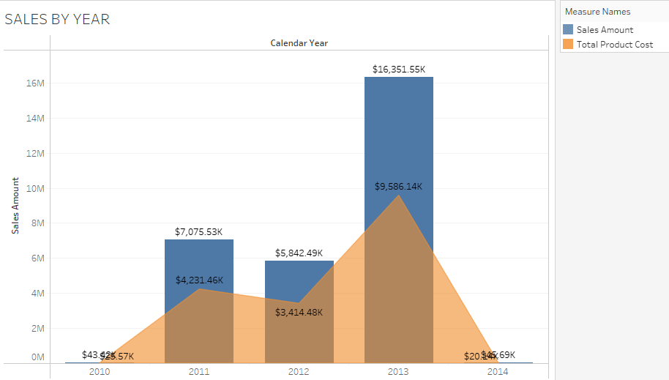

1. Create Line Chart as below using English Month Name , Year and Sales Amount

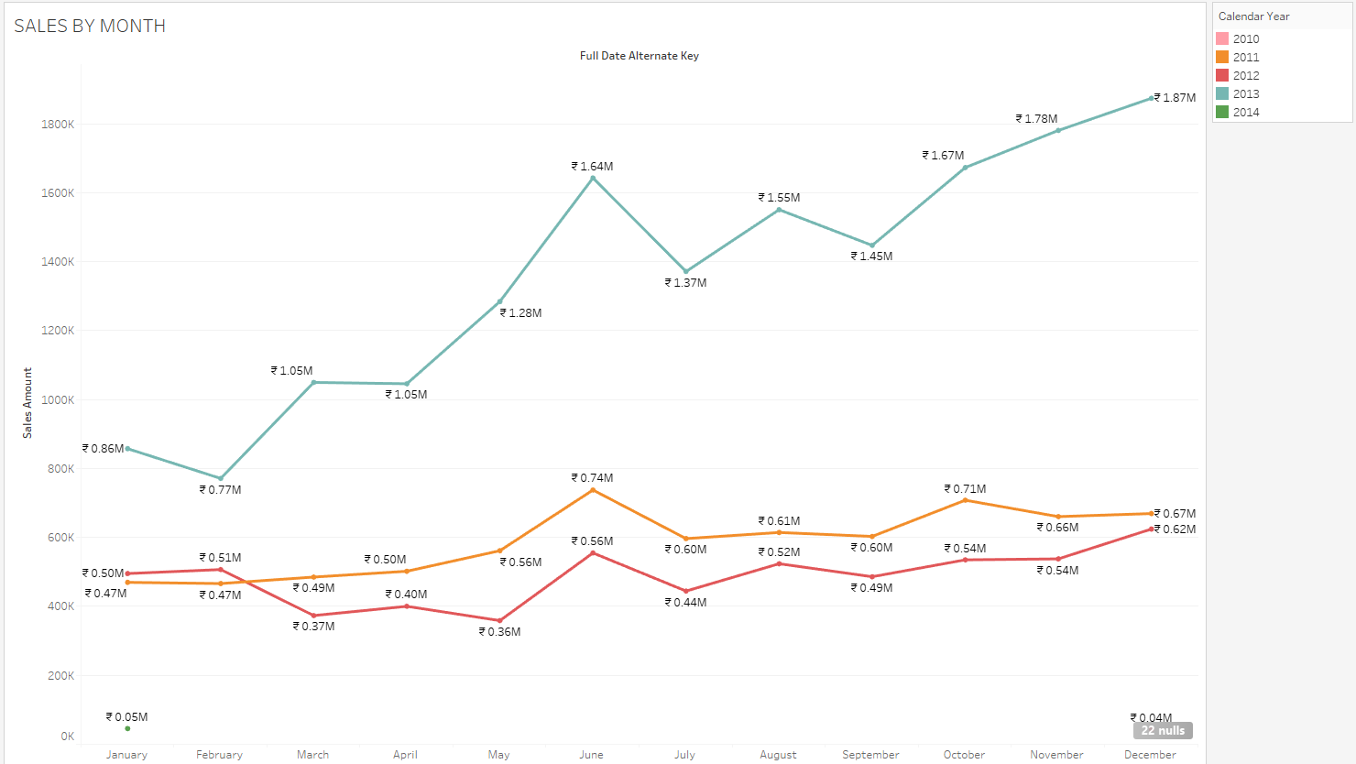

1. Create Donut Chart as below

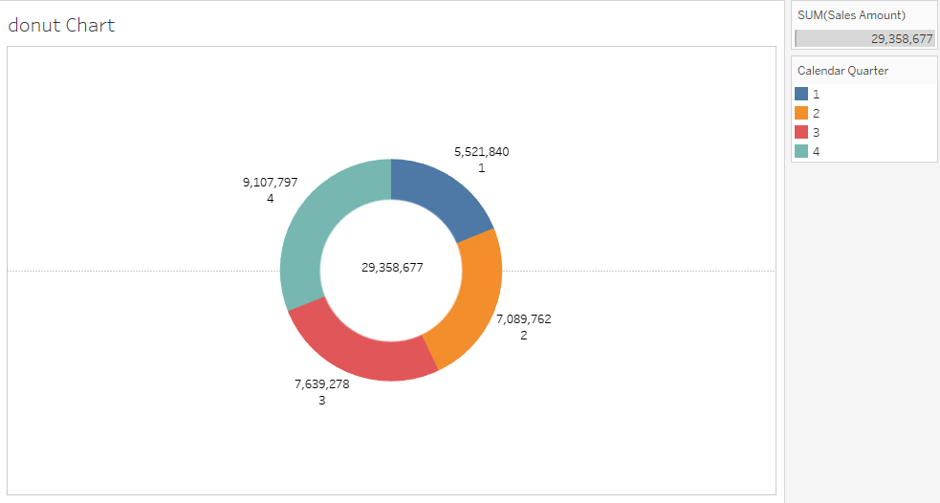

1. Create a crosstab , Ensure the Formatting , Border and Color Scheme

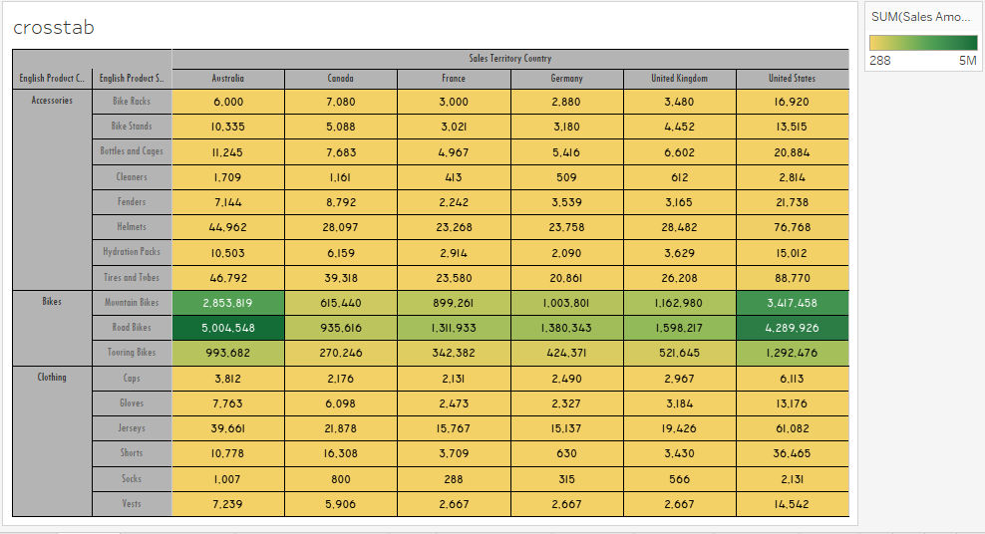

1. Create the Below Bar chart with the option for user to Switch between the SALES, COST, PROFIT using parameter, Title of the Chart also should Change Accordingly

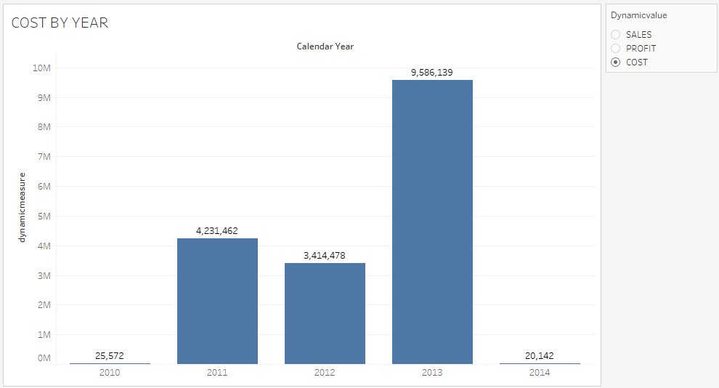

1. Create a TOP N chart as below using Parameter.

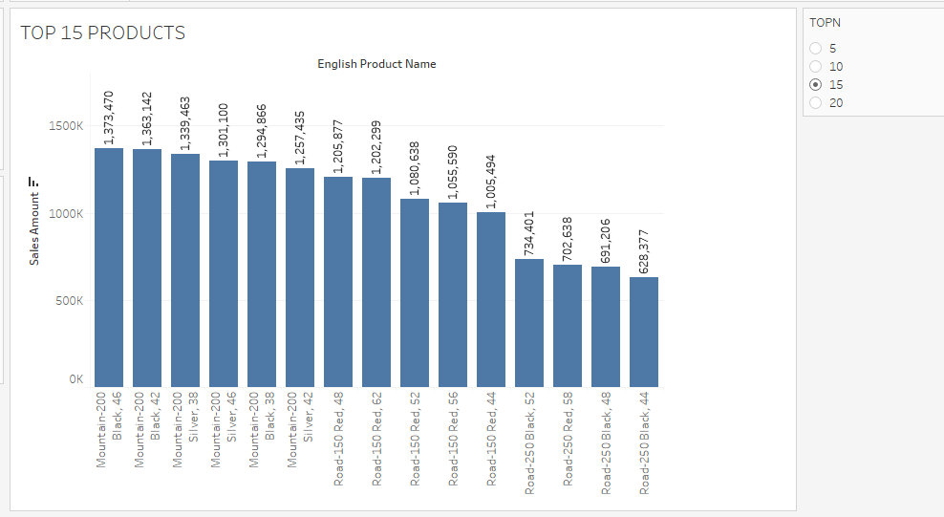

1. Create Advanced Funnel Chart as below for Country vs SalesAmount

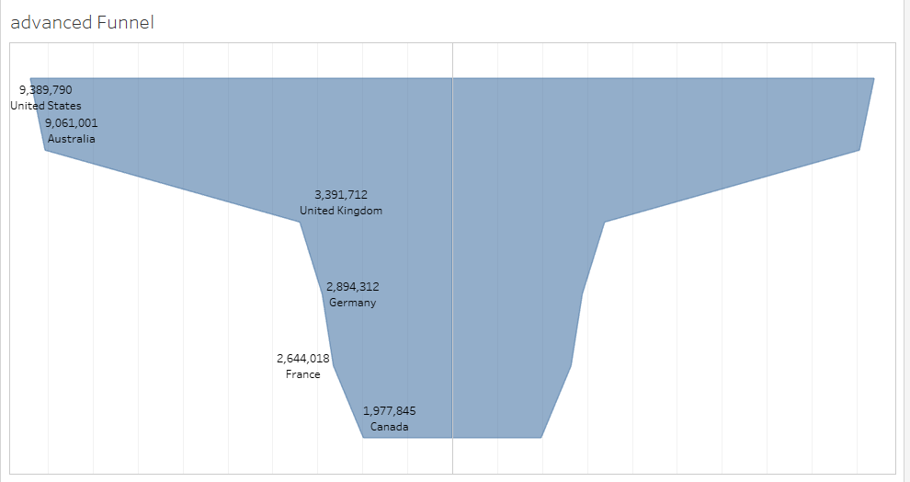

1. Create a Pareto Chart as Below Using English Product Name and Sales Amount.

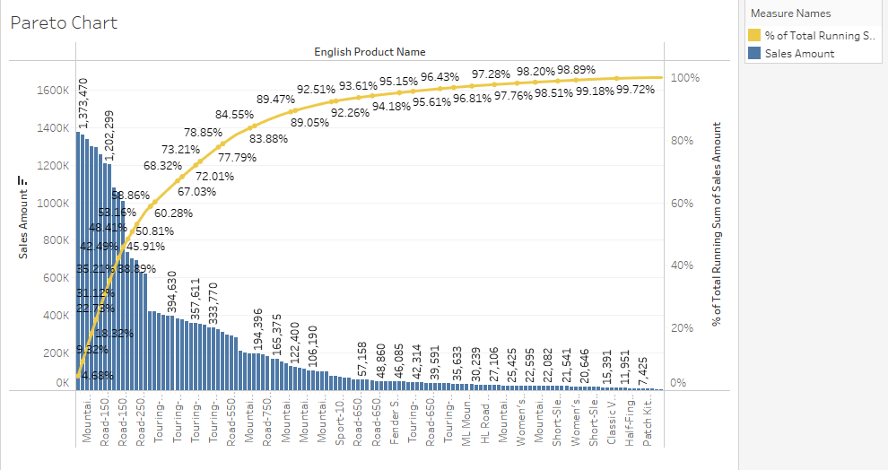

1. Create Bump Chart using English Monthname , Salesterritory Country and Sales Rank.

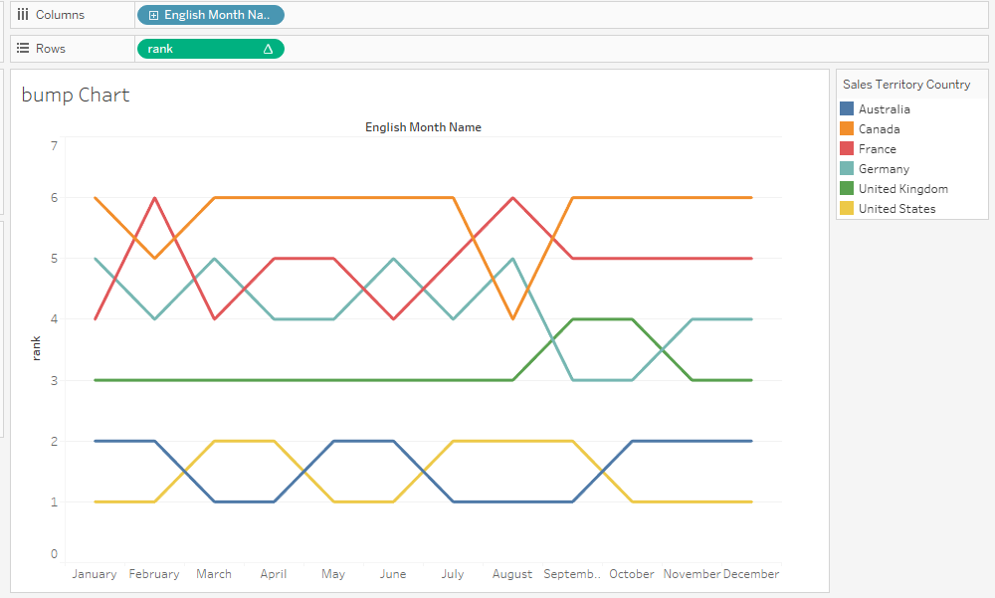

1. Create a KPI worksheet as below



1. Create a Dashboard as Show below using the Tiled Approach.

Using Actions to do follows operations:

Clear Filters

Go to Sheet Navigation: Back and Next Buttons

Highlight action to highlight line chart if hover over Bar chart

Download Button to Download the Report.

